AI Assisted Coding
Assignment Number: 8.1
Hall Ticket: 2303A51730
Batch: 11
Task Description #1 (Password Strength Validator – Apply AI in Security Context)
- Task: Apply AI to generate at least 3 assert test cases for is_strong_password(password) and implement the validator function.
- Requirements:
  - Password must have at least 8 characters. o Must include uppercase, lowercase, digit, and special character. o Must not contain spaces.
Prompt:
#generate a python code for password validation and must have 8 characters, at least one uppercase letter, one lowercase letter, one digit and one special character.
Code:

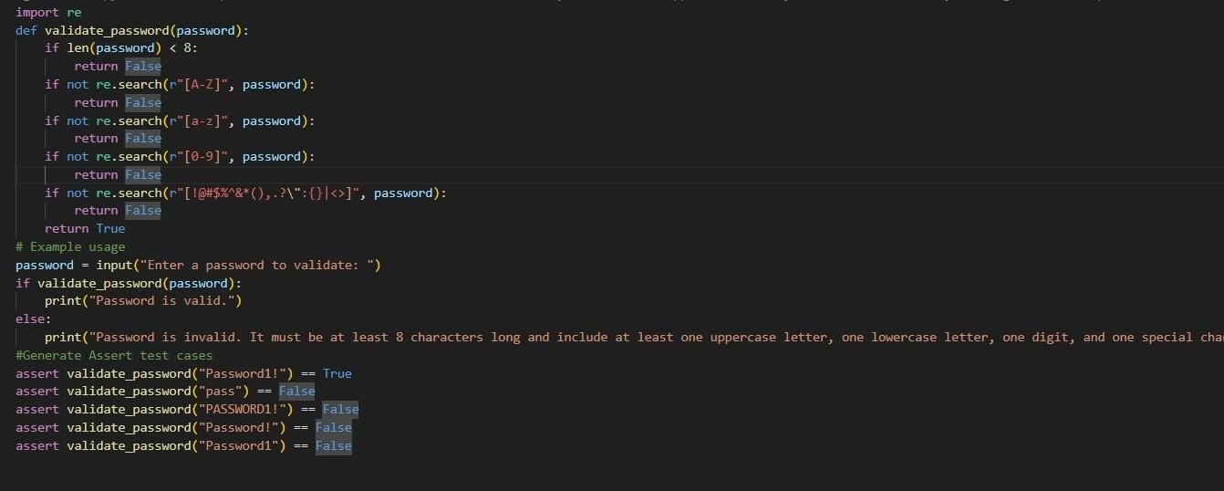
Output:

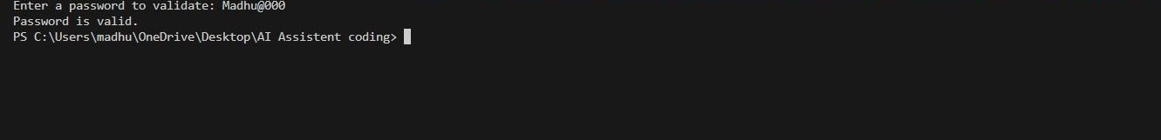
Observation:
  - The function correctly checks minimum password length (≥ 8 characters).
  - Regular expressions are used to enforce uppercase, lowercase, digit, and special character rules.
  - Validation stops early using return False when any condition fails.
  - The special character regex is restrictive and only allows a specific set of symbols.
  - Example usage takes input from the user and prints a clear validation message.
  - Assert statements at the end act as basic test cases to verify expected behavior.

Task Description #2 (Number Classification with Loops – Apply
AI for Edge Case Handling)
- Task: Use AI to generate at least 3 assert test cases for a classify_number(n) function.
Implement using loops.
- Requirements: o Classify numbers as Positive, Negative, or Zero. o Handle invalid inputs like strings and None.
  - Include boundary conditions (-1, 0, 1).
Prompt:
#Generate a Python function classify_number(n) using loops to classify input as Positive, Negative, or Zero, and handle invalid inputs like strings and None.
#Also generate at least 3 assert test cases, including boundary values -1, 0, 1, ensuring all tests pass.
Code:
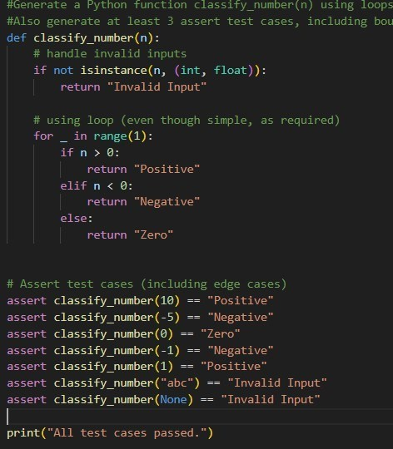
Observations:
  - The function correctly classifies numbers as Positive, Negative, or Zero.
  - A loop is used to satisfy the implementation requirement, even for simple logic.
  - Invalid inputs like strings and None are safely handled without errors.
  - Boundary values −1, 0, and 1 are explicitly tested using assert statements.
  - Assert tests help verify correctness and catch edge cases early.
  - The program confirms successful execution by printing a final message.

Task Description #3 (Anagram Checker – Apply AI for String Analysis)
- Task: Use AI to generate at least 3 assert test cases for is_anagram(str1, str2) and implement the function.
- Requirements: o Ignore case, spaces, and punctuation. o Handle edge cases (empty strings, identical words).
Prompt:
#Genertae a function to check if two strings are anagrams ignoring case and spaces.Handle edge cases like empty strings and non-string inputs.
#Generate at least 3 assert test cases to validate the function.
Code:

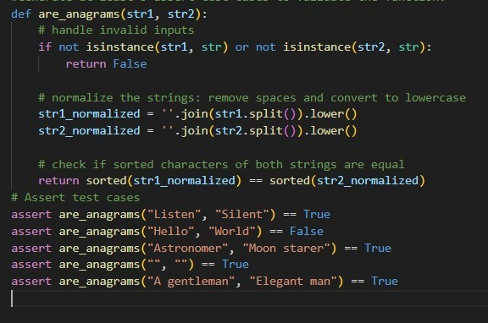
Output:

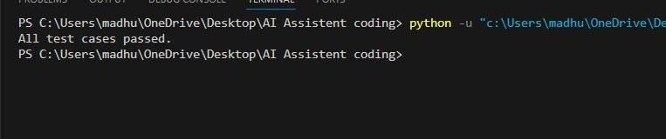
Observation:
- The function effectively ignores both letter casing and extra spaces by normalizing the input strings before comparison, ensuring accurate anagram detection.
- By sorting the characters of the normalized strings, the function uses a clear and dependable approach to determine whether the two inputs are anagrams.
- Invalid inputs such as non-string values are properly handled with an early return, preventing runtime errors and improving robustness.
- Empty strings are logically considered valid anagrams since they contain no characters, and this edge case is correctly addressed.
- The assert test cases comprehensively validate correct behavior for matching anagrams, non-anagrams, and special edge conditions.
- The success message printed at the end confirms that all test cases executed without errors and the function works as expected.
Task Description #4 (Inventory Class – Apply AI to Simulate Real-World Inventory System)
- Task: Ask AI to generate at least 3 assert-based tests for an Inventory class with stock management.
- Methods:
o add_item(name, quantity) o remove_item(name, quantity) o get_stock(name) Prompt:
#Generate a python code for Inoventory class to stock management with methods to add, remove, and check stock levels of items.
Code:

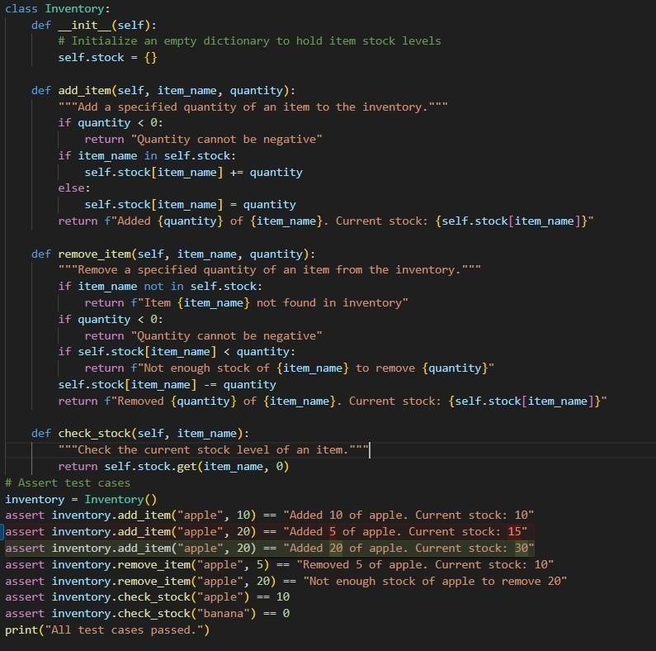
Output:

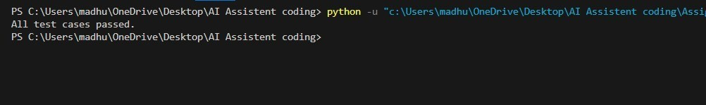
Obsevation:
  - The Inventory class uses a dictionary to efficiently store and manage stock levels for different items.
  - The add_item method properly handles both new and existing items while preventing negative quantities from being added.
  - The remove_item method includes thorough checks for item existence, sufficient stock availability, and invalid quantities, making it robust.
  - The check_stock method safely returns the current quantity of an item and defaults to zero when the item is not present.
  - Assert test cases validate normal operations such as adding and removing items as well as edge cases like insufficient stock and missing items.
  - The final confirmation message ensures that all inventory operations work correctly and pass every test case.

Task Description #5 (Date Validation & Formatting – Apply AI for Data Validation)
- Task: Use AI to generate at least 3 assert test cases for validate_and_format_date(date_str) to check and convert dates.
- Requirements:
o Validate "MM/DD/YYYY" format. o Handle invalid dates. o Convert valid dates to "YYYY-MM-DD".
Prompt:
#Generate a python code for Date Validation and Formatting to check and convert date strings in 'DD-MM-YYYY' format.
Code:
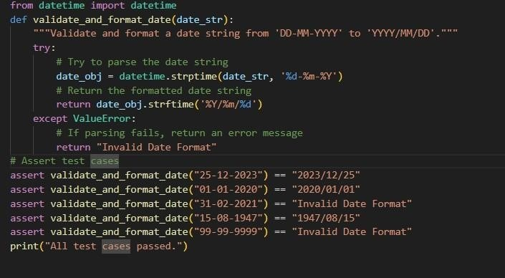
Output:

Observations:
- The function accurately validates date strings by attempting to parse them using the specified DD-MM-YYYY format.
- The datetime.strptime method ensures that both the date structure and calendar validity (such as leap years and month lengths) are correctly checked.
- Valid date inputs are consistently converted into the standardized YYYY/MM/DD output format.
- Invalid or impossible dates are safely handled using exception handling, preventing program crashes.
- The assert test cases cover valid dates, invalid calendar dates, and incorrect values to ensure robustness.
- The final print statement confirms that all validation and formatting scenarios pass successfully.

